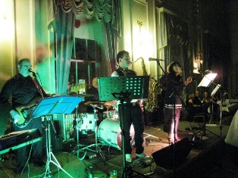

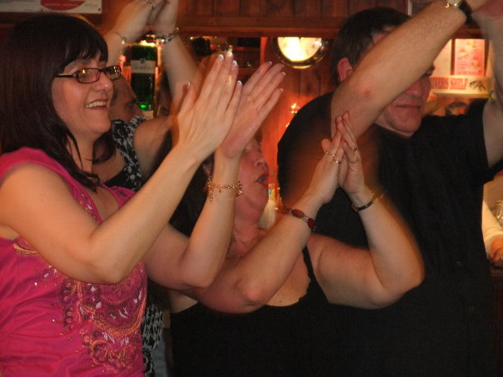

Pizazz 6 piece party and function band
Tel: 01279 319677 / 07928 654554
E-mail: rongray46@gmail.com
Web: www.pizazzband.co.uk



6 Piece Party and Function Band

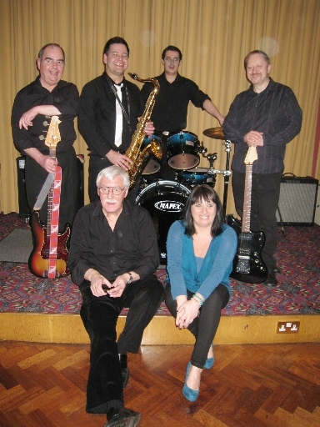

Parties, Dinner Dances, Weddings, Proms, Clubs,
Pubs, Corporate Functions, Festivals, Events
Top Class music from the 50’s to today

Pizazz

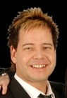 | Spike  (Lead vocal / sax / trumpet) | Music to suit all tastes with songs from  The Beatles  Elvis Presley  Duffy  Amy Winehouse  Adele  Jessie J  Abba  Emili Sandé  The Trammps  Donna Summer  John Travolta &  Olivia Newton-John  Labelle  Robbie Williams  Kylie Minogue  Gerry Rafferty  The Monkees  Queen  Etta James  Wilson Pickett  The Supremes  Dion & The Belmonts  The Kinks  Status Quo  The Righteous Brothers  Sister Sledge  The Rolling Stones  Tina Turner  Gloria Gaynor  Buddy Holly  Elton John  Kings Of Leon  Stereophonics  Madness  Sweet  and many more
Elaine  (Lead vocal) | 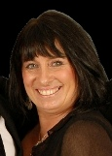
 | Ronnie  (Keyboards)
Rob  (Guitar) | 
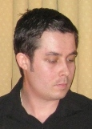 | Shane  (Drums)
Dave  (Bass guitar / vocals) | 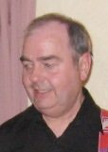
Pizazz are experienced and professional. They know how to create a lively and fun atmosphere. The band’s intent is to play music from any era that is great to dance to, so that you can party hard.

The band’s repertoire covers music from all eras, 50’s & 60’s rock ‘n’ roll, 70’s disco, with dance numbers from the 80’s, 90’s & 00’s.

Pizazz 6 piece party and function band
Tel: 01279 319677 / 07928 654554
E-mail: rongray46@gmail.com
Web: www.pizazzband.co.uk

We have many excellent bands perform here and we give them marks out of ten. You've scored 10 ½ out of 10. We loved Pizazz, you were so good, playing the music we love. We're definitely having you back! Stanstead Abbotts & St. Margarets Village Club (09 Nov 2013)

Tonight was the best night we've ever had, and Pizazz are the best band we've ever had. Manager, Rifleman (17 Sep 2011)

We regularly have bands here. You knocked spots off of all of them. Alan, Haldens Residents Club (04 Dec 2010)

We just wanted to say an ENORMOUS thank you to you and the band for all that you did to help make our wedding day so special. Not only were the band performances top drawer, but the way you were all so helpful and co-operative (not least by allowing Rob to come and play one song with you!!) helped make our day so worry-free. An enormous thank you again, you really were perfect!!
Rob & Laura Mynott (Thursday, June 17, 2010)
I just want to say, you guys were really good, and nice to work alongside. I will definitely recommend you to potential clients in the future. Jonathan Waterman (Professional Toastmaster & Master Of Ceremonies)

